True Distributed Virtual Compiler Editor

Deepak Mistry,Deepak pagar,Tejas jadhav,Sumit Wakde

Sinhgad Institute of technology and Science,Pune

Universtiy of Pune

***Abstract: Distributed computing is a model for enabling convenient, on-demand network access to a shared pool of configurable computing resources that can be rapidly provisioned and released with minimal management effort. The paper aims to describe an compiler which help to reduce the problem of probability and storage space by making use of the concept of distributed computing. The ability to use different compilers allow a programmer to pick up the fastest or more convenient tool to compile the code and remove the errors. Moreover an,applicationcan be used remotely throughout any network connection (wired/wireless and it is platform independent .The errors/outputs) of code are more convenient way.Also,trouble of installing the compiler on each computer is avoided.Thus,these advantages make this application ideal for conducting examinations.***

***Keywords –Backup Compiler, Distributed computing, Compiler***

**1. INTRODUCTION**

Distributed computing builds on decades of research in virtualization, utility computing, and more recently networking, web and software services.

It implies a service oriented architecture, reduced information technology overhead for the end-user, great flexibility, reduced total cost of ownership and on-demand services among other advantages. The National Institute of Standards and Technology (NIST) defines ‘Distributed Computing’ as ‘a model for enabling easy, on-demand network access to a shared pool of configurable computing resources(e.g.,networks,servers,storage,applications,and

services) that can be rapidly provisioned and released with minimal management effort or service provider interaction. It does not require the end-user to know the physical location and configuration of the system that provides these services to the end

user. The main disadvantage of distributed computing is the loss of control over the infrastructure used by the users. However, this disadvantage is eclipsed by many an advantages that distributed computing offers. Some of them are lower costs, better computing, location independence, better security. There are five known ways of providing distributed computing currently viz. public, private, community, combined and hybrid computing. A compiler, which is the heart of any computing system, transforms source code from a higher level language to a lower, machine level language. This is mainly done in order to create executable files which can then be ‘run’ in order to execute the program and its instructions. Every compiler primarily consists of three parts viz.

1. The Front end: This checks the semantics and syntax of higher level code (written by the user).Other functions like type checking and error reporting are also performed by the frontend.
2. The middle end: This performs the optimization though removal or useless code, relocation of computation depending on the correct.
3. The backend: This is the part where the translation of the language actually takes place.

**II. NEED FOR PROJECT**

The main advantage of distributed computing is of faster processing. Also, many processors can be used remotely,without the knowledge of the user(s), in order to expedite the processing. Thus, keeping this main advantage in mind, the main reason for creating the project is to provide a centralized compiling scheme for organizations or institutions. Also, it will act as a centralized repository for all the codes written. The other major advantage that this system will have over the others is that it will make the users system lightweight i.e. there will be no need to maintain separate compilers/SDK’s at the client-side. Thus, for educational institutions this will prove to be highly efficient. Also, the process of maintenance and distribution of dynamic usernames and passwords will be greatly simplified. Also; authentication and personalized task distribution will be made possible.

**III. BACKUP COMPILER**

The primary functions of our project are:

***Compile option:*** This would take the code in the text box to the server side for its compilation and at the server side the compiler package has been imported.

***Execute Option:*** The user is provided with the links of all the executable files that were present in his or her folder and were already compiled at least once without errors. ***Start test option:*** Till this button is not clicked the test does not start and the student cannot start writing the code.

All programs and their timestamps of when were they compiled are stored at the server side database. The user(s) paste/write the code in the main window and the compiler compiles it and stores an executable file in its database. This .exe file can then be accessed directly and downloaded to the user’s terminal.

**IV. JAVA – AN INTRODUCTION**

**Java** is a set of several [computer software](http://en.wikipedia.org/wiki/Computer_software) products and specifications from [Sun Microsystems](http://en.wikipedia.org/wiki/Sun_Microsystems) (which has since merged with [Oracle Corporation](http://en.wikipedia.org/wiki/Oracle_Corporation)), that together provide a system for developing [application software](http://en.wikipedia.org/wiki/Application_software) and deploying it in a [cross-platform](http://en.wikipedia.org/wiki/Cross-platform) computing environment. Java is used in a wide variety of [computing platforms](http://en.wikipedia.org/wiki/Computing_platform) from [embedded devices](http://en.wikipedia.org/wiki/Embedded_device) and [mobile phones](http://en.wikipedia.org/wiki/Mobile_phone) on the low end, to [enterprise servers](http://en.wikipedia.org/wiki/Enterprise_server) and [supercomputers](http://en.wikipedia.org/wiki/Supercomputer) on the high end. While less common, [Java applets](http://en.wikipedia.org/wiki/Java_applet) are sometimes used to provide improved and secure functions while browsing the [World Wide Web](http://en.wikipedia.org/wiki/World_Wide_Web) on [desktop computers](http://en.wikipedia.org/wiki/Desktop_computer).

**A. ADVANTAGES**

Distributed computing involves several computers on a network working together. Java is designed to make distributed computing easy with the networking capability that is inherently integrated into it. Writing network programs in Java is like sending and receiving data to and from a file.

**B.DISADVANTAGES**

Applications using the java tend to use much of the system resources . Also, loss of trade secrets and by passing of license is the major problem caused by reverse engineering. Regular garbage check and collection makes the application pause for sometime from execution.

**V.PROJECT ARCHITECTURE**

The system uses a tri-layered architecture. The lower layer consists of clients, which are of lower configuration. The middle

layer consists of the central server.The upper layer consist of backend server for compiling purpose.The important components of the middle & upper layers are described as below:

1. A net beans, which handles the work of scripting and compilation of code.

2. IIS sever to handle the client request.

3. Database which stores the client information.

4. The ‘Central server hard disk’ is a shared resource.

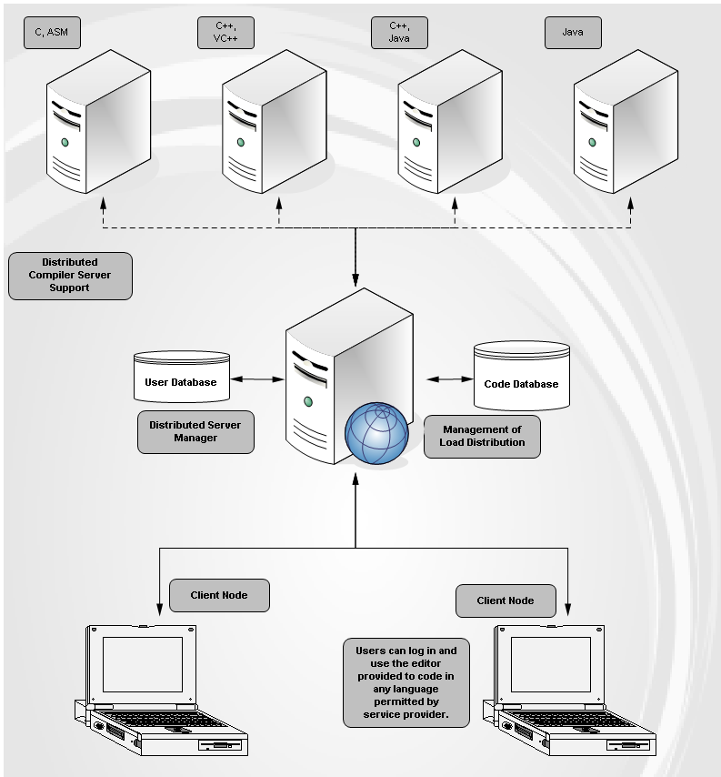

**VI.PROJECT IMPLEMENTATION**

While developing the software it is imperative to decideapriori which programs will be executed on the client sideand which programs are to be executed on the server side.Client side programs are applets which are transferred to theclient machine entirely on the request of the user. They areexecuted only on the client machine and not on the server.This allows for sharing the computational cost between theserver and client.This approach is used when program to be transferred to users is moderate in size, is cached on client machine or the data to be transferred between server and client in case the application is run on the server is very large in volume. In case of platform independent solutions, such as Java,causing lesser computational performance may be prohibitive. With the distributed Compiler, much less information has to be passed on, to the server. The server executes instructions based on the given information and sends the results back to the local machine that made the initial request. This is used when the software package is large or is not to be released to user, or when amount of data to be transferred is small. However, large number of clients that access the server simultaneously would make CGI- based approach undesired. These software design problems were considered and solved in the Distributed Compiler. The user interface is programmed in java language using servlets. It was assumed that the user will use his or her favourite text editor to create and correct program files. This assumption allowed to create a very simple front-end that that loads quickly and is platform independent. Although the front end is designed to be as simple as possible with only a few commonly used options, it is sufficiently functional and can be used quickly. The server side part of the application is implemented using java servlets that handles the communication between a user and compiler.The script does the file managing, runs compilers and processes the compilation results. The result is the source code listing or a list of errors sent back to the user.

**VII. USE OF PROJECT**

The purpose of the project was to allow students to get familiar with different compilers and compiler optimization techniques rather than make another huge GUI application to wrap compilers.

The major use of the ‘Distributed Compiler’ is in conducting university practical examinations through our project. A separate cloud would be constructed at the university location that is the server.

Every student would in advance have a user id and password to log in and start with the examination. There would be a URL provided to the students which would lead them directly to the login page of the application.

**VIII.CONCLUSION**

By integrating and enhancing the capabilities of these essential technologies, we hope to introduce the “Distributed compiler” and to contribute to the current examination system. It would basically be a platform for students to the university to give their practical examination online. There would be a cloud where there will be a server which would have the power to compile the student’s code stored on another machine.

As compared to the current scenario where each machine should have the C/C++ compiler installed separately and an examiner has to visit each machine to check each and every student’code.This would eliminate the need to install compilers separately, the examiner does not need to visit each and every student but check the codes at centrailzedserver as well each student record is maintained for future references. Another advantage of such project is whatever the compiler package is to be upgraded it can be done easily without gain installing it to each and every machine.

**IX.REFERENCE**

1. “Java Server Programming 1.4 Edition”-Black Book.
2. “The Complete Reference”, Patrick Naughton, Herbert Schildt.
3. “Core Servlets and Java Server Pages” , Marty Hall, Larry Brown

4. Sweet, W. and Geppert, L., “http:// It has changed everything, especially our engineering thinking,” *IEEE Spectrum*, January 1997, pp. 23-37.

5. Camposano, R.; Deering, S.; DeMicheli, G.; Markov, L.; Mastellone, M.; Newton, A.R.; Rabaey, J.; Rowson, J.; “What’s ahead for Design on the Web”, *IEEE Spectrum,* September 1998, pp. 53-63.

6. Hank Shiffman, Making Sense of Java, http://www.disordered.org/Java-QA.html

7. Hank Shiffman, Boosting Java Performance: Native Code and JIT Compilers,

http://www.disordered.org/Java-JIT.html

8. Gundavaram, S.,. *CGI Programming on the World Wide Web.* OReilly & Associates, Inc., 1996.

9. Wall,L., Christiansen, T., Schwartz, R.L. *Programming Perl,* OReilly & Associates, Inc., 1996